## HANG GLIDING/PARAGLIDING RULES

General:

Transporting equipment to takeoff sites will be done by hand carry on established trails.

Standards established by the U. S. Hang Gliding Association will apply, as well as all applicable laws and regulations imposed by Federal and other governmental agencies. These include: ·

1. Wear a safety helmet.
2. Have launch assistance.
3. Consider the safety of everyone in the area.
4. Do not fly if five gliders are already in the air.
5. Report all accidents resulting in injury and/or damage to property to the National Park Service.
6. Land only in designated landing zones.

Pyramid Point

All flights at Pyramid Point will be initiated from the blowout at the top of the bluff.

All pilots landing on the beach below Pyramid Point will exit the area via the trail that ends at the east end of the dune area. The face of the bluff will be avoided, and will not be climbed. Pilots may also land in the field east of the Klett Farm or in the field that is south of Baker Road and east of Port Oneida Road.

Lake Michigan Overlook

Flights at Lake Michigan Overlook will originate in the blowout area to the south of the viewing platform. Flights may originate north of the viewing platform ONLY when cross winds at the blowout area make launching hazardous.

When landing in the North Bar Lake area, please respect the privacy of cottage owners along the beach north and south of North Bar Lake. Landings may be made at Lake Michigan Overlook only when visitor use is light and landing presents no hazard to visitors or the pilot.

.'

Dune Climb

Hang gliding or paragliding is allowed on the east face of the Dune Climb from November 1st to March 31st of each year. Activities will be limited to the sand areas of the dune that do not have vegetation.

Landings will take place either on top of the Dune Climb or in the grassy area below the Dune climb.

Empire Bluff

All f1ights at Empire Bluff are to be initiated south of a point where the

Trail comes to the Bluff edge. Take off is to be no more than 15 feet (4.57 meters) from the trail without climbing vertically up or down the bluff face.

All pilots landing on the beach below Empire Bluff are to exit via the beach north to Empire Beach or south to Esch Road. The face of the bluff is to be avoided, and must not be climbed.

## RADIO CONTROLLED MOTORLESS MODEL AIRCRAFT RULES

1. Pennits may be issued for the calender year.
2. The number of aircraft in the air at any one time and location is limited to ten.
3. Locations for flights are the same as for paragliding and hang gliding:
   1. Pyramid Point
   2. Lake Michigan Overlook
   3. Dune Climb (November l - March 31 only)
   4. Empire Bluff
4. When more than one permit is issued for the same area it is the responsibility of the flyers to reconcile any radio frequency problems.

THE FLYING OF ANY **POWERED** MODEL AIRCRAFT WITHIN THE LAKESHORE IS PROHIBITED BY TITLE 36, CODE OF FEDERAL REGULATIONS

2.17 (AIRCRAFT) AND 2.12 (AUDIO DEVICES).

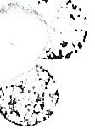

NSTRUCTIONS FOR ISSUTNG HANG GLIDrNG/PARAGLIDrNG PERi'vlITS

l. Have pilot applicant complete the application form and sign it. Yerify with proper identification.

7 Check pilot's certificate to be certain the Hang Gliding Association number and proficiency rating are correctly recorded on the application.

3. Issuing ranger signs the application if it is satisfactory and assigns a Lakeshore number to the permit.

4 Hang·Gliders: If the pilot has a level H-2 rating, write "Valid for Dune Climb or Lake Michigan Overlook Only" in the space provided on the permit. If the pilot has an H-3 or higher, write "Valid at all Lakeshore Flight-Approved Locations"

1. Paragliders: · If the pilot has a P-2 rating, write "Not Valid at Pyramid Point" across the top of the permit. If the pilot has a P-3 rating or higher, write "Valid at all Lakeshore Flight-Approved Locations".
2. Make sure you call attention to the rules so the pilot understands them.

·-._

*4* '

1. Make a copy of the permit for our files, and give the completed and signed original back to the pilot. Also give the pilot copies of the landing zone maps and rules.
2. 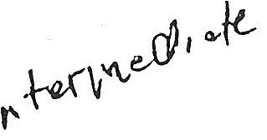Send a £QQY of the permit to the Dispatch Office for filing.
3. Where can they fly?

|  |  |  |  |  |  |  |  |
| --- | --- | --- | --- | --- | --- | --- | --- |
| **Locatio.n:f\ S Ra,t,ing** ·,**;** | **::,::·:H-2.:.)\,-...** | **:: ::.J;.} :P 2.} ;:{** | -_**·**.. **·**•**·**:**·**·**•H**.**"***.***3***:***+***-.:***·-***-***'***·***"***:***·**-.:**.**·-**.**·..:.-- | --**·**--·: |  | **p***:·* **'J**.-. **'+**-:. | : |
| Pyramid Point | **No** | **No** | Yes | Yes | | | |
| Lake Michigan Overlook | Yes | Yes | Yes | Yes | | | |
| Dune Climb ( 11/ l -/3/31 Only) | Yes | Yes | Yes | Yes | | | |
| Empire Bluff | **No** | Yes | Yes | Yes | | | |

Refer to page 2 of plan for ratmgs explanations or compansons.

5

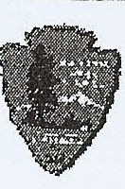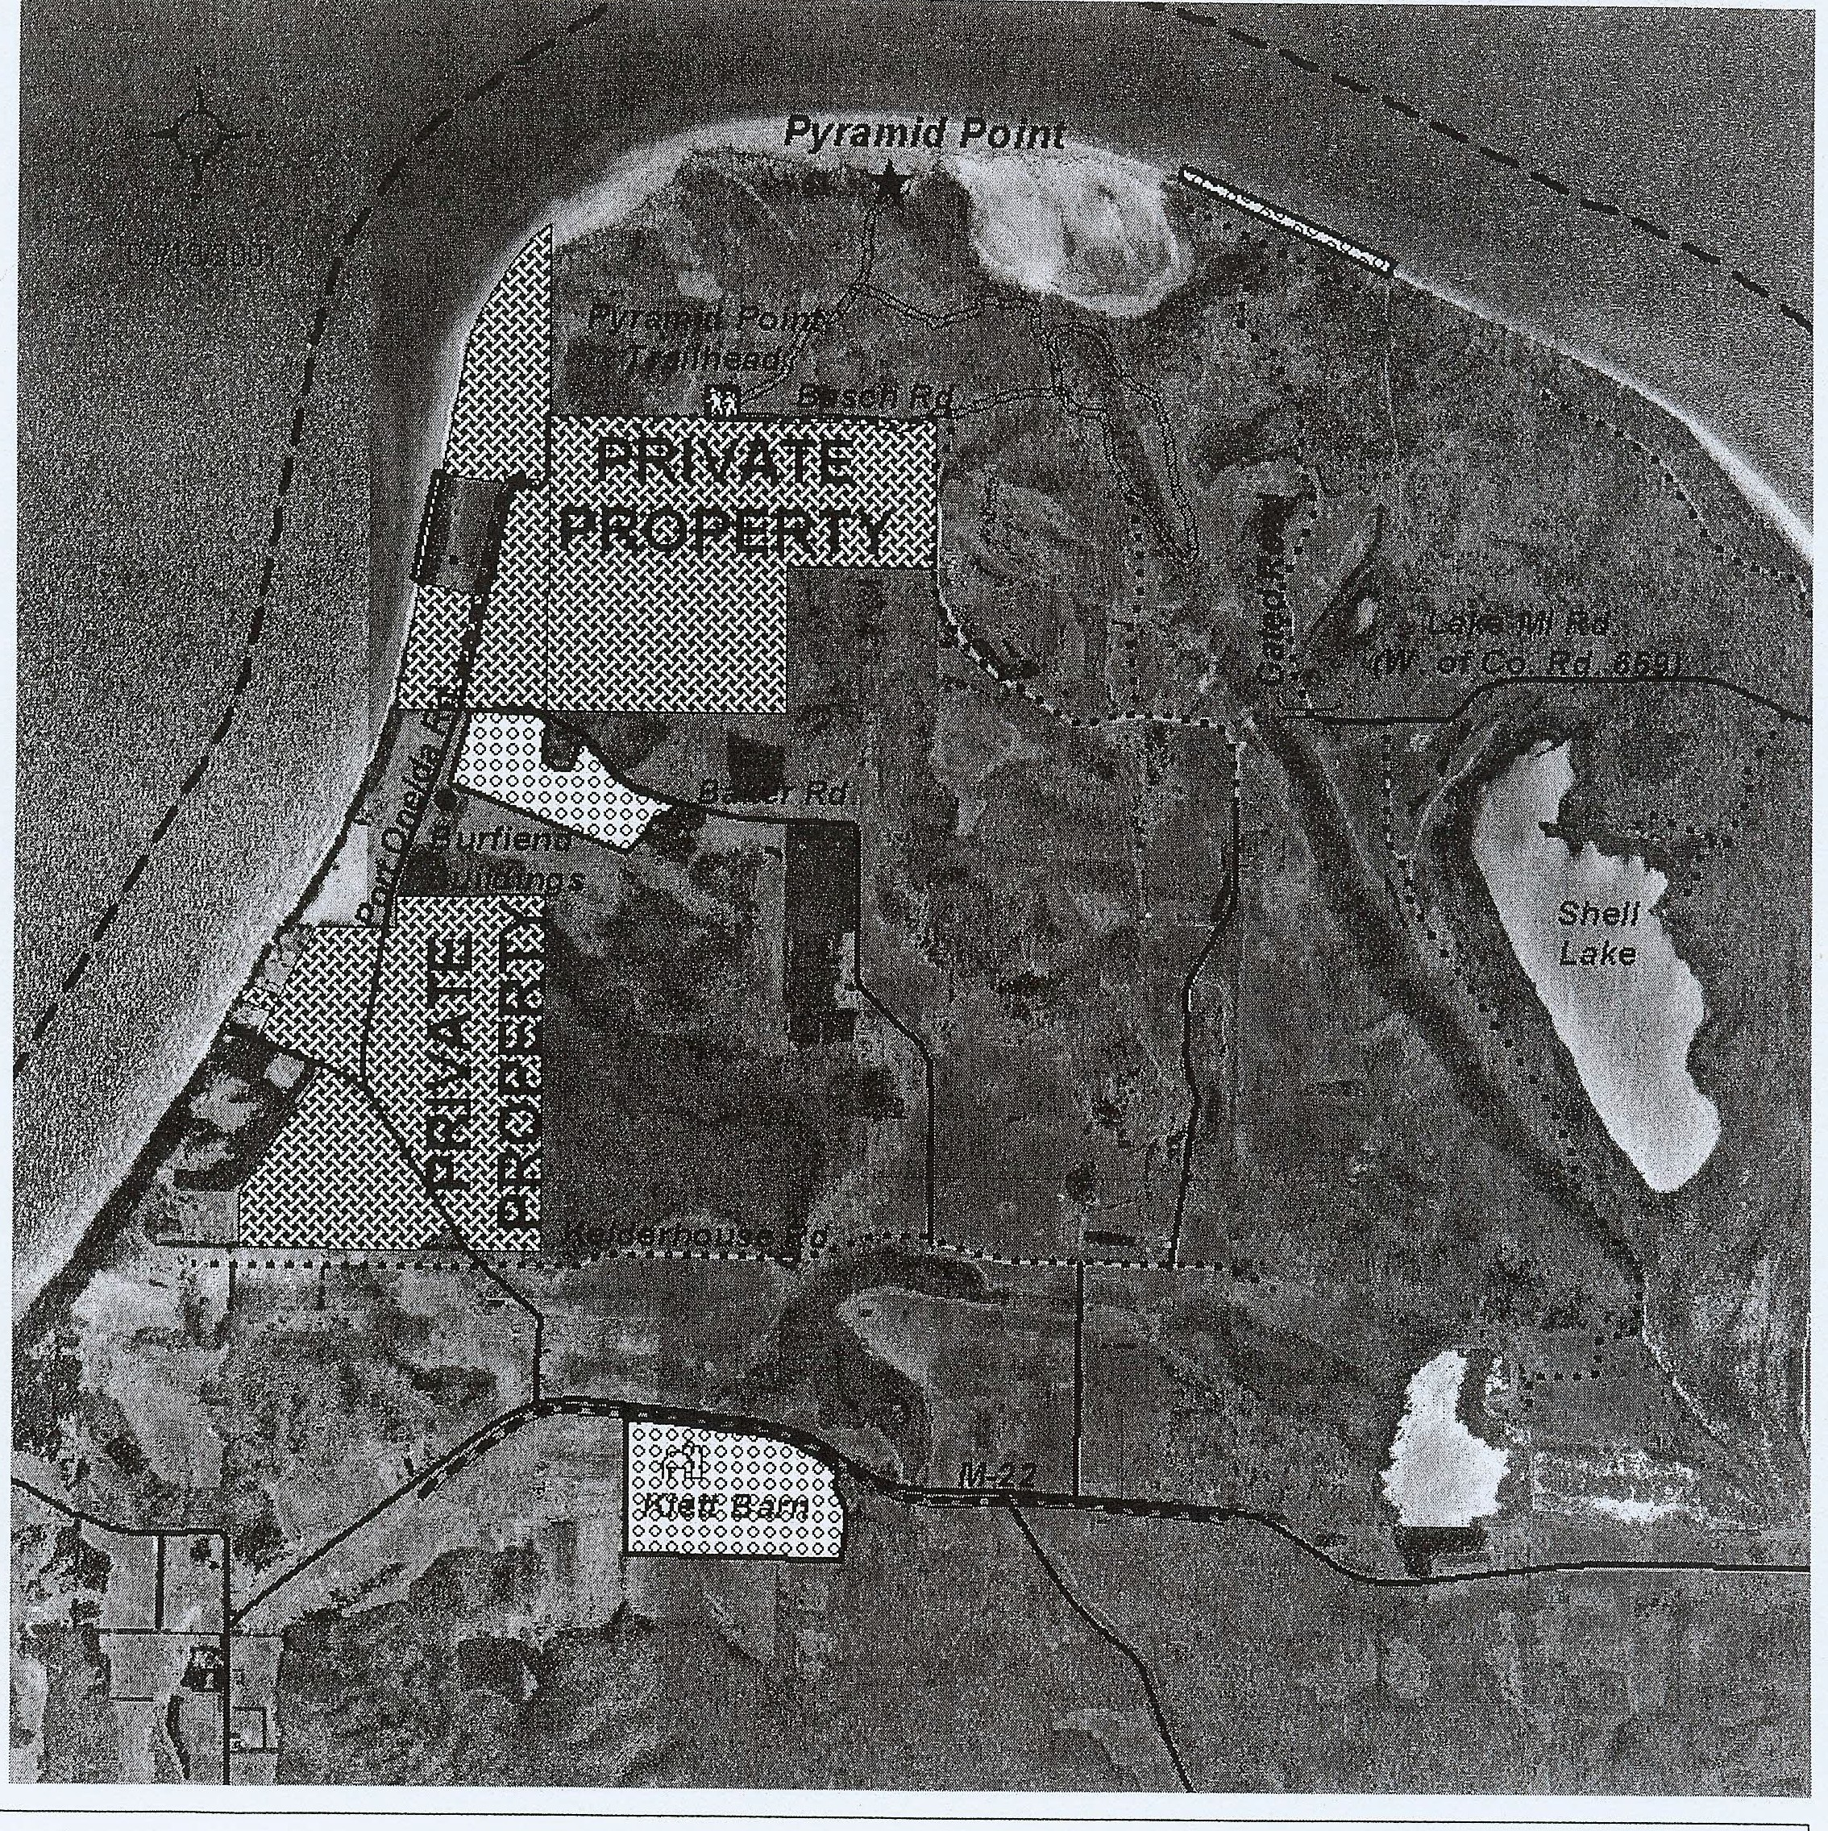

**LEGEND**

Power Lin es

iggggg,

Hang-Gliding & Paragliding Landing Zones

Lakes h ore Boundary

*

0.2

0

0.2

0.4 Miles

Powerless Flight Laun oh Site

Se as on al Roads

Year-Round Maintained Ro ads

0.3

0

0.3

o.6 Kilo meters

# Sleeping Bear Dunes National Lakeshore

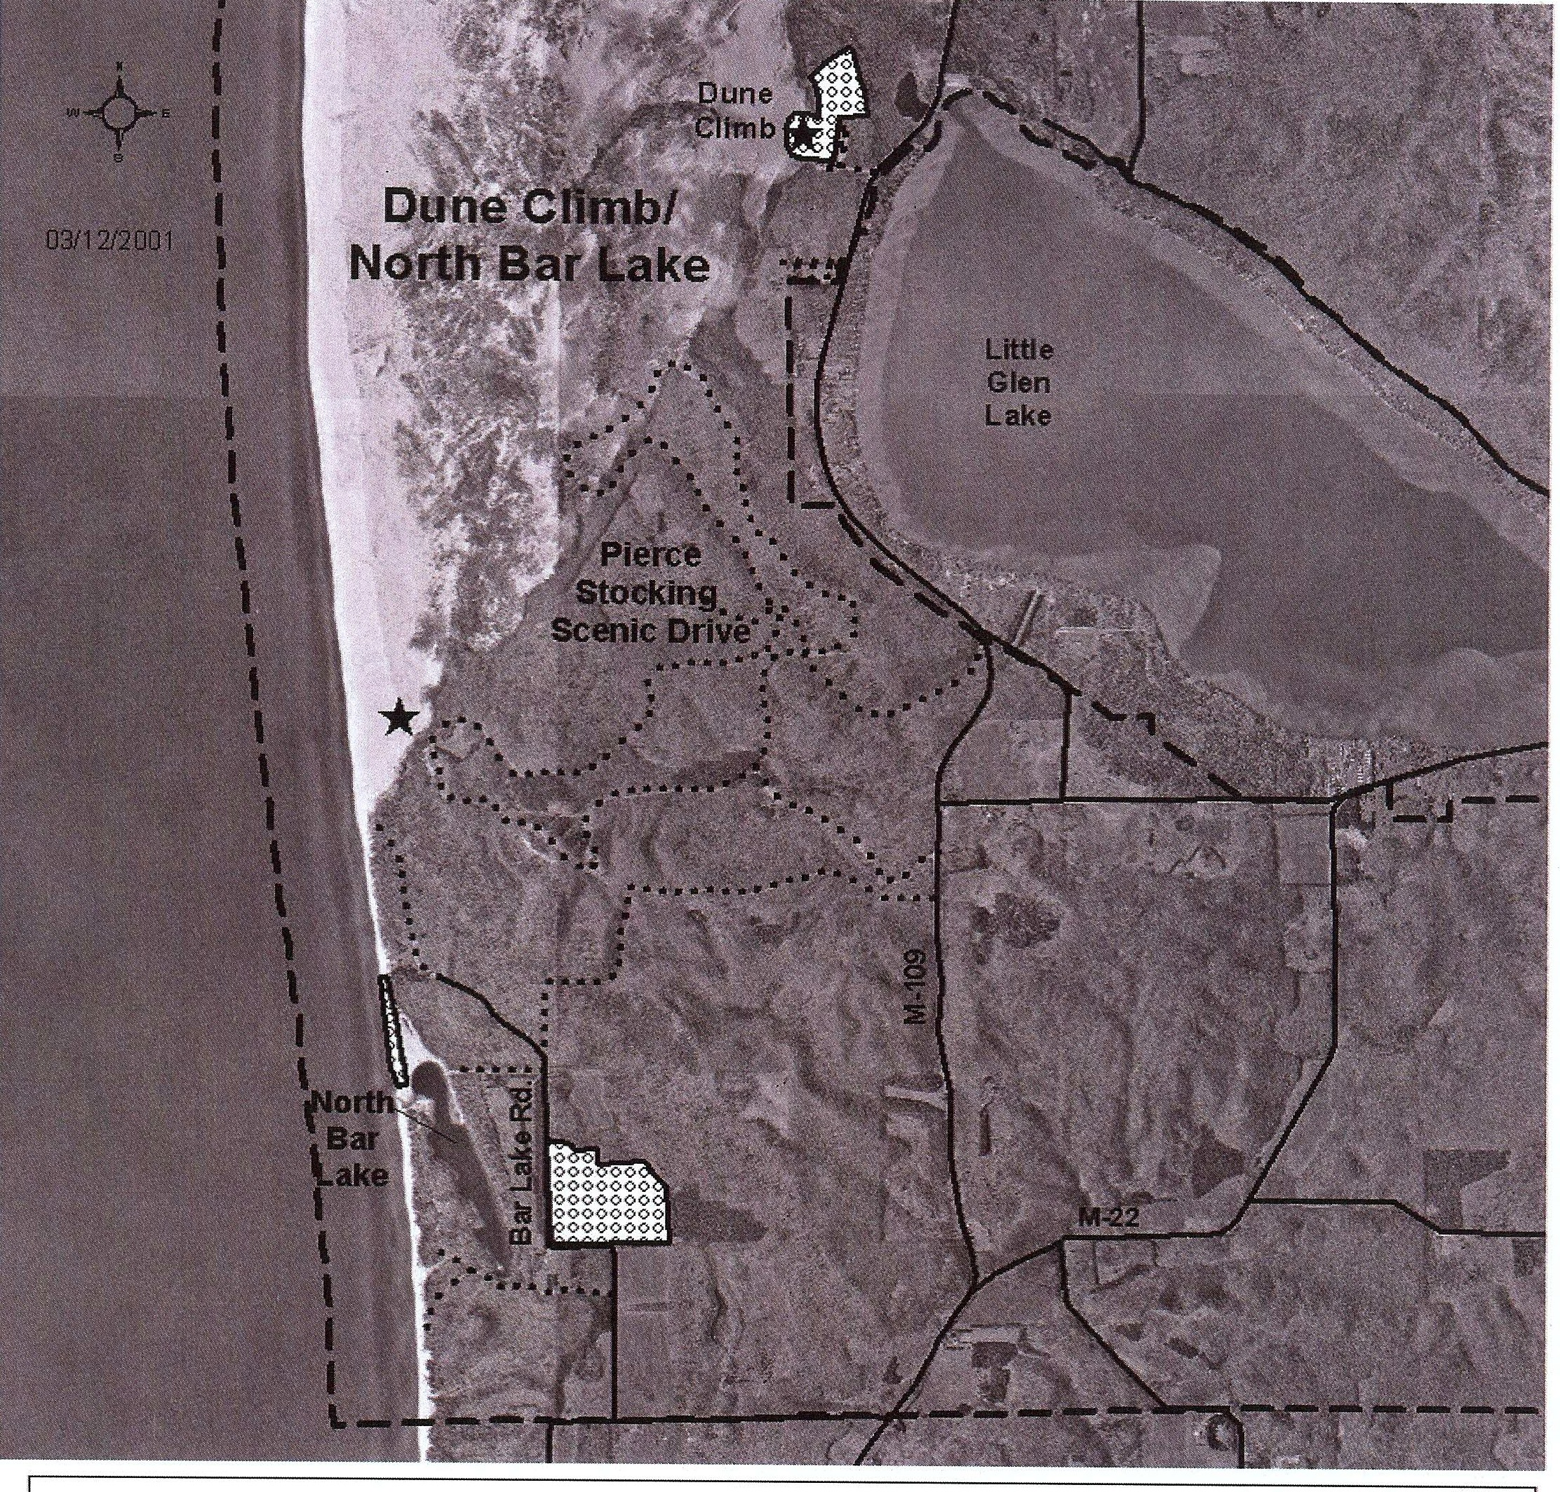

**LEGEND**

000000

000000

*

Powerless **Flight Launch** Site

Year-Round Maintained Roads

Hang-Gliding & **Paragliding** Landing Zones

Lakeshore Boundary

Seasonal Roads

0.2 O

**P"""""I**

0.2 0.4 Miles

0.4

0

0.4 0.8 Kilometers

' **Sleeping Bear Dunes National Lakes_hore**

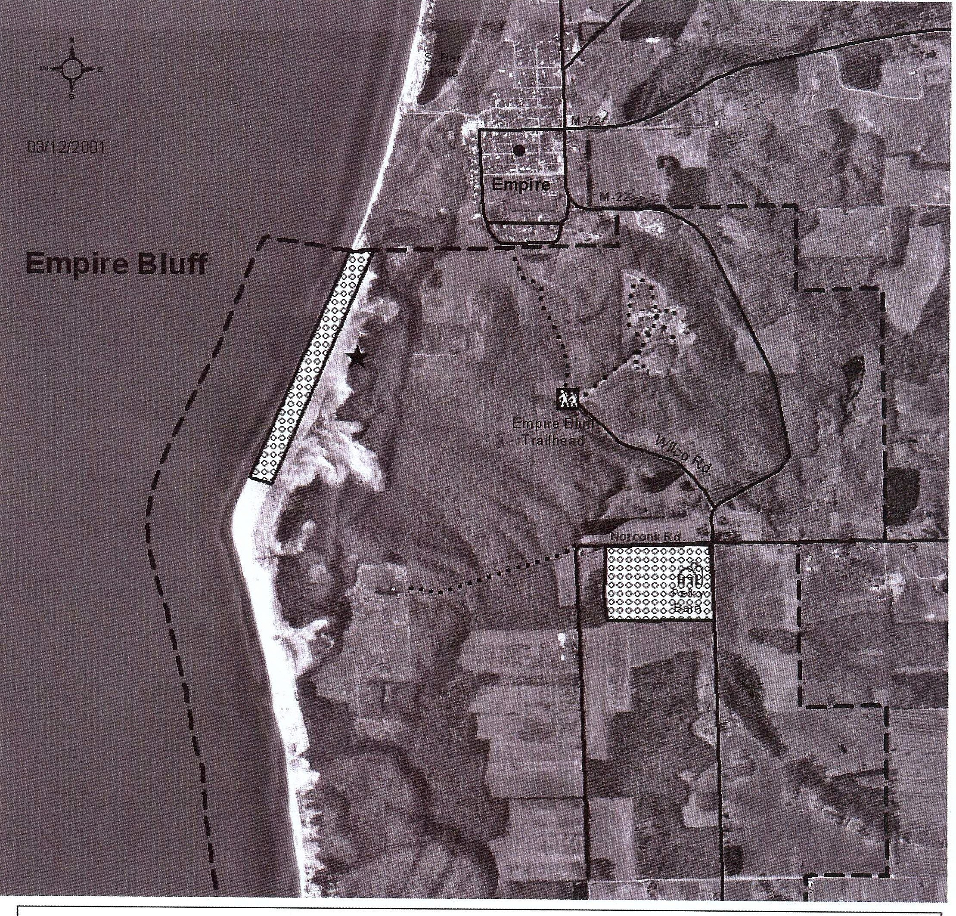

' **Sleeping Bear Dunes National Lakes_hore**,

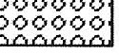

**LEGEND**

*

Powerless Flight **Laund1** Site

Year-Round Maintained Roads

Hang-Gliding & **Paragliding** Landing Zones

Lakeshore Boundary

Seasonal Roads 0.2 0 0.2 0.4 Miles

0.,.2....... 0

0.2 0.4 Kilometers